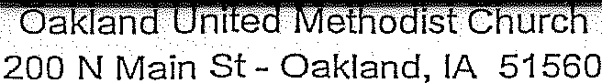

Automatic Giving is a reliable and safe way to tithe to the church. It allows you to share your donations through planned giving and activates your generosity into ongoing stewardship. Because your donation is given consistently, you won't need to play "catch-up" at year-end or worry about forgotten checkbooks or missed Sunday offerings. But you are not the only one that benefits. Oakland United Methodist Church benefits from steady, more predictable revenues throughout the year, more efficient bookkeeping, and greater confidence in meeting its financial commitments.

Enrollment/Update Instructions: Indicate whether this is a new enrollment or a change in authorized amount or frequency and/or a change in bank. Complete the personal information section including name, address and telephone number (e-mail address optional). Designate the fund(s) where you'd like your donation to go and the amount· Total the donation amount. Select the frequency of your contribution. Enter the date you want this "to take effect (please allow one week for processing). For new enrollment or change in bank account, complete the Bank Account box. Sign and date in the Bank Account box.
Return the completed form to the church office or place in the offering plate.

Complete this section for ALL ENROLLMENTS
Check the appropriate box(es): New Enrollment  or  change in Amount - Frequency change in Bank | Last Name |  | First Name | M.I.
 | Mailing Address
 | City |  | State | zip
 | Telephone. |  | E-Mail

DESIGNATE AMOUNT | FREQUENCY OF DONATION
,.  · Amount Per Donation  TOTAL DONATION AMOUNT $ (min $5)  Please note that if the requested withdrawal date fails on a weekend or bank holiday, the funds  will be withdrawn the following business day. | Frequency of Donation: Please check only one  Weekly on Monday  Semi-Monthly  (transferred on 1st and 15th of each month)  Monthly on the 1st Monthly on the 15th  Date to Begin _  (please allow one week for processing)

- .
BANK ACCOUNT
Donations should be taken from:  checking (attach voided check)  l | REQUJRED:  I authorize Oakland United Methodist Church to automatically withdraw donations from my account. This authority will remain in effect until I give  reasonable notification to terminate the authorization.  .  Account Holder Signature _____________________
savings

Routing Number _________________________
/
Account Number _________________________

Bank Name _________________________
 | Date
'

Return completed form to the church office or place in the offering plate.

